**Error occured when create a vm**

Error message - " The template deployment failed with multiple errors. Please see details for more information."

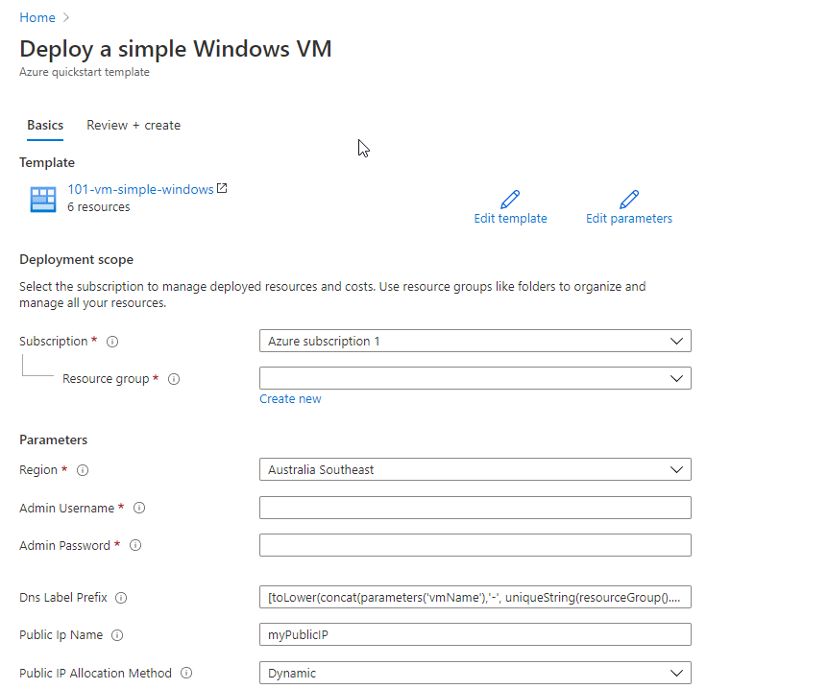**Be careful when creating a VM using this link** [**https://portal.azure.com/#create/Microsoft.Template**](https://portal.azure.com/#create/Microsoft.Template) **This link direct you to a deploy simple Windows VM screen , this page do not come with selections. See the normal VM creation page below.**

**Normal VM creating screen  
You can see there a selection tabs showing below “Create a virtual machine” title.**   
  
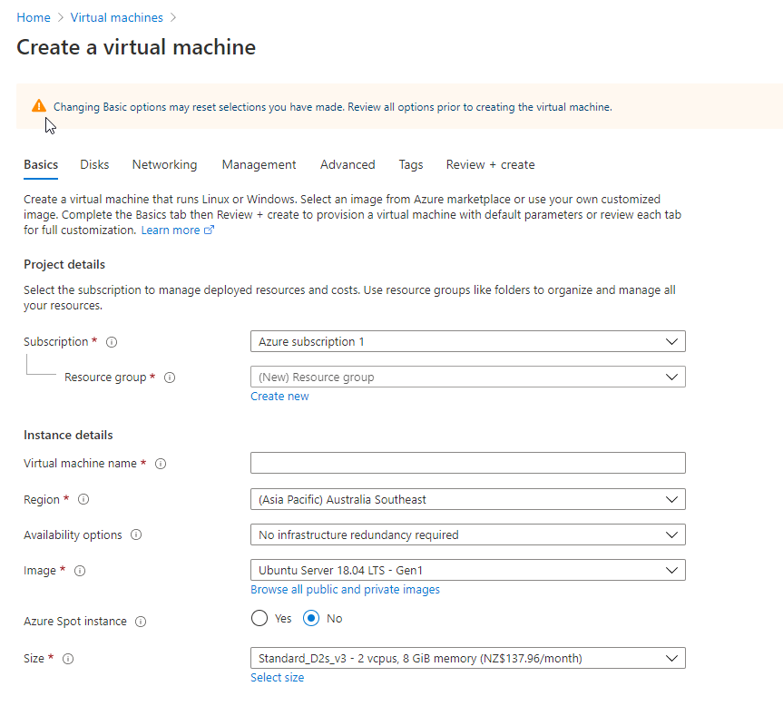

**Reason:** There was a lab teaching the way how to setup policy on Azure. The definition name was Enforce tag on resource, purpose was to ensure that all resources have the "Department" tag associated with them and block creation if it doesn't exist.

**Problem solve options**  
**option 1**: turn off the definition   
If you are creating your vm using the link, it will not create a vm if you have the definition “Enforce tag on resource” turn on, due to there a no “Tag” option.   
  
**option 2**: create your vm in a normal way  
If you are creating your vm using the normal vm page, remember to add tag before select review + create button on the button  
  
check your resources group tag when creating a group

check the definition name in Policy

eg:

"policyDefinitionDisplayName": "Enforce tag on resource"

**Example error :**

{

"deploymentStatusCode": -1,

"stage": 6,

"expected": true,

"error": {

"message": "The template deployment failed with multiple errors. Please see details for more information."

},

"subscriptionId": "cadf6f2b-8537-4829-aede-75fc90459ce0",

"resourceGroupName": "production-learn-rg",

"resourceGroupLocation": "eastus",

"deploymentName": "Microsoft.Template-20201103145652",

"details": {

"code": "InvalidTemplateDeployment",

"message": "The template deployment failed with multiple errors. Please see details for more information.",

"details": [

{

"code": "RequestDisallowedByPolicy",

"target": "bootdiagsw7zjfkl2ycsji",

"message": "Resource 'bootdiagsw7zjfkl2ycsji' was disallowed by policy. Policy identifiers: '[{\"policyAssignment\":{\"name\":\"Enforce tag on resource\",\"id\":\"/subscriptions/cadf6f2b-8537-4829-aede-75fc90459ce0/providers/Microsoft.Authorization/policyAssignments/6b0ad23cf176433d9c977f87\"},\"policyDefinition\":{\"name\":\"Enforce tag on resource\",\"id\":\"/subscriptions/cadf6f2b-8537-4829-aede-75fc90459ce0/providers/Microsoft.Authorization/policyDefinitions/98a4af80-b835-478f-8995-4f6f6cbf12b9\"}}]'.",

"additionalInfo": [

{

"type": "PolicyViolation",

"info": {

"policyDefinitionDisplayName": "Enforce tag on resource",

"evaluationDetails": {

"evaluatedExpressions": [

{

"result": "True",

"expressionKind": "Field",

"expression": "tags[Department]",

"path": "tags[Department]",

"targetValue": "false",

"operator": "Exists"

}

]

},

"policyDefinitionId": "/subscriptions/cadf6f2b-8537-4829-aede-75fc90459ce0/providers/Microsoft.Authorization/policyDefinitions/98a4af80-b835-478f-8995-4f6f6cbf12b9",

"policyDefinitionName": "98a4af80-b835-478f-8995-4f6f6cbf12b9",

"policyDefinitionEffect": "deny",

"policyAssignmentId": "/subscriptions/cadf6f2b-8537-4829-aede-75fc90459ce0/providers/Microsoft.Authorization/policyAssignments/6b0ad23cf176433d9c977f87",

"policyAssignmentName": "6b0ad23cf176433d9c977f87",

"policyAssignmentDisplayName": "Enforce tag on resource",

"policyAssignmentScope": "/subscriptions/cadf6f2b-8537-4829-aede-75fc90459ce0",

"policyAssignmentParameters": {

"tagName": {

"value": "Department"

}

}

}

}

]

},

{

"code": "RequestDisallowedByPolicy",

"target": "myPublicIP",

"message": "Resource 'myPublicIP' was disallowed by policy. Policy identifiers: '[{\"policyAssignment\":{\"name\":\"Enforce tag on resource\",\"id\":\"/subscriptions/cadf6f2b-8537-4829-aede-75fc90459ce0/providers/Microsoft.Authorization/policyAssignments/6b0ad23cf176433d9c977f87\"},\"policyDefinition\":{\"name\":\"Enforce tag on resource\",\"id\":\"/subscriptions/cadf6f2b-8537-4829-aede-75fc90459ce0/providers/Microsoft.Authorization/policyDefinitions/98a4af80-b835-478f-8995-4f6f6cbf12b9\"}}]'.",

"additionalInfo": [

{

"type": "PolicyViolation",

"info": {

"policyDefinitionDisplayName": "Enforce tag on resource",

"evaluationDetails": {

"evaluatedExpressions": [

{

"result": "True",

"expressionKind": "Field",

"expression": "tags[Department]",

"path": "tags[Department]",

"targetValue": "false",

"operator": "Exists"

}

]

},

"policyDefinitionId": "/subscriptions/cadf6f2b-8537-4829-aede-75fc90459ce0/providers/Microsoft.Authorization/policyDefinitions/98a4af80-b835-478f-8995-4f6f6cbf12b9",

"policyDefinitionName": "98a4af80-b835-478f-8995-4f6f6cbf12b9",

"policyDefinitionEffect": "deny",

"policyAssignmentId": "/subscriptions/cadf6f2b-8537-4829-aede-75fc90459ce0/providers/Microsoft.Authorization/policyAssignments/6b0ad23cf176433d9c977f87",

"policyAssignmentName": "6b0ad23cf176433d9c977f87",

"policyAssignmentDisplayName": "Enforce tag on resource",

"policyAssignmentScope": "/subscriptions/cadf6f2b-8537-4829-aede-75fc90459ce0",

"policyAssignmentParameters": {

"tagName": {

"value": "Department"

}

}

}

}

]

},

{

"code": "RequestDisallowedByPolicy",

"target": "default-NSG",

"message": "Resource 'default-NSG' was disallowed by policy. Policy identifiers: '[{\"policyAssignment\":{\"name\":\"Enforce tag on resource\",\"id\":\"/subscriptions/cadf6f2b-8537-4829-aede-75fc90459ce0/providers/Microsoft.Authorization/policyAssignments/6b0ad23cf176433d9c977f87\"},\"policyDefinition\":{\"name\":\"Enforce tag on resource\",\"id\":\"/subscriptions/cadf6f2b-8537-4829-aede-75fc90459ce0/providers/Microsoft.Authorization/policyDefinitions/98a4af80-b835-478f-8995-4f6f6cbf12b9\"}}]'.",

"additionalInfo": [

{

"type": "PolicyViolation",

"info": {

"policyDefinitionDisplayName": "Enforce tag on resource",

"evaluationDetails": {

"evaluatedExpressions": [

{

"result": "True",

"expressionKind": "Field",

"expression": "tags[Department]",

"path": "tags[Department]",

"targetValue": "false",

"operator": "Exists"

}

]

},

"policyDefinitionId": "/subscriptions/cadf6f2b-8537-4829-aede-75fc90459ce0/providers/Microsoft.Authorization/policyDefinitions/98a4af80-b835-478f-8995-4f6f6cbf12b9",

"policyDefinitionName": "98a4af80-b835-478f-8995-4f6f6cbf12b9",

"policyDefinitionEffect": "deny",

"policyAssignmentId": "/subscriptions/cadf6f2b-8537-4829-aede-75fc90459ce0/providers/Microsoft.Authorization/policyAssignments/6b0ad23cf176433d9c977f87",

"policyAssignmentName": "6b0ad23cf176433d9c977f87",

"policyAssignmentDisplayName": "Enforce tag on resource",

"policyAssignmentScope": "/subscriptions/cadf6f2b-8537-4829-aede-75fc90459ce0",

"policyAssignmentParameters": {

"tagName": {

"value": "Department"

}

}

}

}

]

},

{

"code": "RequestDisallowedByPolicy",

"target": "MyVNET",

"message": "Resource 'MyVNET' was disallowed by policy. Policy identifiers: '[{\"policyAssignment\":{\"name\":\"Enforce tag on resource\",\"id\":\"/subscriptions/cadf6f2b-8537-4829-aede-75fc90459ce0/providers/Microsoft.Authorization/policyAssignments/6b0ad23cf176433d9c977f87\"},\"policyDefinition\":{\"name\":\"Enforce tag on resource\",\"id\":\"/subscriptions/cadf6f2b-8537-4829-aede-75fc90459ce0/providers/Microsoft.Authorization/policyDefinitions/98a4af80-b835-478f-8995-4f6f6cbf12b9\"}}]'.",

"additionalInfo": [

{

"type": "PolicyViolation",

"info": {

"policyDefinitionDisplayName": "Enforce tag on resource",

"evaluationDetails": {

"evaluatedExpressions": [

{

"result": "True",

"expressionKind": "Field",

"expression": "tags[Department]",

"path": "tags[Department]",

"targetValue": "false",

"operator": "Exists"

}

]

},

"policyDefinitionId": "/subscriptions/cadf6f2b-8537-4829-aede-75fc90459ce0/providers/Microsoft.Authorization/policyDefinitions/98a4af80-b835-478f-8995-4f6f6cbf12b9",

"policyDefinitionName": "98a4af80-b835-478f-8995-4f6f6cbf12b9",

"policyDefinitionEffect": "deny",

"policyAssignmentId": "/subscriptions/cadf6f2b-8537-4829-aede-75fc90459ce0/providers/Microsoft.Authorization/policyAssignments/6b0ad23cf176433d9c977f87",

"policyAssignmentName": "6b0ad23cf176433d9c977f87",

"policyAssignmentDisplayName": "Enforce tag on resource",

"policyAssignmentScope": "/subscriptions/cadf6f2b-8537-4829-aede-75fc90459ce0",

"policyAssignmentParameters": {

"tagName": {

"value": "Department"

}

}

}

}

]

},

{

"code": "RequestDisallowedByPolicy",

"target": "myVMNic",

"message": "Resource 'myVMNic' was disallowed by policy. Policy identifiers: '[{\"policyAssignment\":{\"name\":\"Enforce tag on resource\",\"id\":\"/subscriptions/cadf6f2b-8537-4829-aede-75fc90459ce0/providers/Microsoft.Authorization/policyAssignments/6b0ad23cf176433d9c977f87\"},\"policyDefinition\":{\"name\":\"Enforce tag on resource\",\"id\":\"/subscriptions/cadf6f2b-8537-4829-aede-75fc90459ce0/providers/Microsoft.Authorization/policyDefinitions/98a4af80-b835-478f-8995-4f6f6cbf12b9\"}}]'.",

"additionalInfo": [

{

"type": "PolicyViolation",

"info": {

"policyDefinitionDisplayName": "Enforce tag on resource",

"evaluationDetails": {

"evaluatedExpressions": [

{

"result": "True",

"expressionKind": "Field",

"expression": "tags[Department]",

"path": "tags[Department]",

"targetValue": "false",

"operator": "Exists"

}

]

},

"policyDefinitionId": "/subscriptions/cadf6f2b-8537-4829-aede-75fc90459ce0/providers/Microsoft.Authorization/policyDefinitions/98a4af80-b835-478f-8995-4f6f6cbf12b9",

"policyDefinitionName": "98a4af80-b835-478f-8995-4f6f6cbf12b9",

"policyDefinitionEffect": "deny",

"policyAssignmentId": "/subscriptions/cadf6f2b-8537-4829-aede-75fc90459ce0/providers/Microsoft.Authorization/policyAssignments/6b0ad23cf176433d9c977f87",

"policyAssignmentName": "6b0ad23cf176433d9c977f87",

"policyAssignmentDisplayName": "Enforce tag on resource",

"policyAssignmentScope": "/subscriptions/cadf6f2b-8537-4829-aede-75fc90459ce0",

"policyAssignmentParameters": {

"tagName": {

"value": "Department"

}

}

}

}

]

},

{

"code": "RequestDisallowedByPolicy",

"target": "simple-vm",

"message": "Resource 'simple-vm' was disallowed by policy. Policy identifiers: '[{\"policyAssignment\":{\"name\":\"Enforce tag on resource\",\"id\":\"/subscriptions/cadf6f2b-8537-4829-aede-75fc90459ce0/providers/Microsoft.Authorization/policyAssignments/6b0ad23cf176433d9c977f87\"},\"policyDefinition\":{\"name\":\"Enforce tag on resource\",\"id\":\"/subscriptions/cadf6f2b-8537-4829-aede-75fc90459ce0/providers/Microsoft.Authorization/policyDefinitions/98a4af80-b835-478f-8995-4f6f6cbf12b9\"}}]'.",

"additionalInfo": [

{

"type": "PolicyViolation",

"info": {

"policyDefinitionDisplayName": "Enforce tag on resource",

"evaluationDetails": {

"evaluatedExpressions": [

{

"result": "True",

"expressionKind": "Field",

"expression": "tags[Department]",

"path": "tags[Department]",

"targetValue": "false",

"operator": "Exists"

}

]

},

"policyDefinitionId": "/subscriptions/cadf6f2b-8537-4829-aede-75fc90459ce0/providers/Microsoft.Authorization/policyDefinitions/98a4af80-b835-478f-8995-4f6f6cbf12b9",

"policyDefinitionName": "98a4af80-b835-478f-8995-4f6f6cbf12b9",

"policyDefinitionEffect": "deny",

"policyAssignmentId": "/subscriptions/cadf6f2b-8537-4829-aede-75fc90459ce0/providers/Microsoft.Authorization/policyAssignments/6b0ad23cf176433d9c977f87",

"policyAssignmentName": "6b0ad23cf176433d9c977f87",

"policyAssignmentDisplayName": "Enforce tag on resource",

"policyAssignmentScope": "/subscriptions/cadf6f2b-8537-4829-aede-75fc90459ce0",

"policyAssignmentParameters": {

"tagName": {

"value": "Department"

}

}

}

}

]

}

]

}

}